Document version of Inducktion campus tour
This is intended for people who are unable to access the tour with a mobile phone or tablet - https://myportfolio.ucl.ac.uk/view/view.php?id=32163

Contents
Start at the Student Centre 2
Next stop: Army Rail Bin 3
Next stop: Beneath Emmy Jr. 5
Next stop: Lush Cop 7
Next stop: Apricot for men 9
Next stop: Soundproof Pretty Land 11
Next stop: Umpire met Sue 13
Next stop: Resiliency Crab 15
Next stop: Trouble Finding Ring Engine 18
Next stop: Cutesy System, Sir 19
Next stop: Architecture Cuddle Van Sign 23
Next stop: Fibrous Symbol Nest 26
Next stop: Coy Ferret 28
Next stop: Ruggage Nuts 30
Next Stop: Fear Hero Gag 33
Next stop: Trench Eel Hat 35
Next Stop: Floss Duty Now 37
Start: Tender Nuts etc 39

Start at the Student Centre
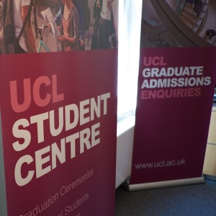
Located on the ground level of the Chadwick Building in the Main Quad, the Student Centre has a walk-in enquiry service which brings together staff from different teams in the UCL Student Advisory and Events Service to answer students' questions - or to tell you where you can go for an answer. For opening times see http://www.ucl.ac.uk/current-students/student-centre.
The service covers:
- any queries you may have about your student record
- submission of research degree theses (viva and final copies)
- enrolment (outside of opening of session)
- any queries you may have about graduation ceremonies
- study abroad queries for UCL students
- international student support.
You can talk to somebody there without an appointment. Another very good source of information is the New Students website at http://www.ucl.ac.uk/new-students .
When you've finished being a New Student, you can find the Current Students website at http://www.ucl.ac.uk/current-students .
Nearby
- The Wilkins Building makes up three sides of the Main Quad. On the remaining side are the Chadwick and Pearson buildings separated by the Front Lodge (entrance from Gower Street).
- Opposite the entrance to the Quad is a huge flight of stone stairs leading to an enormous door - which is locked. To enter the Wilkins building, use one of the ground floor doors instead.
- A bit of orientation - if you're at the Gower Street entrance facing the stone stairs and you look to the left, that's North towards Euston.
Good to know
- Term dates and closures: http://www.ucl.ac.uk/staff/term-dates

Next stop: Army Rail Bin
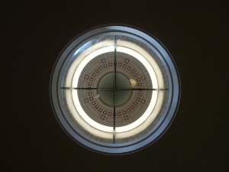
Clue: _ _ _ n _ _ b _ _ _ y
Now go there to find your next Inducktion poster.

Nice work! You have found the Main Library.
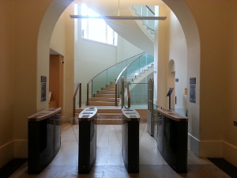
The entrance to the Main Library is inside the Wilkins building, next to the Octagon.
You can find Library information for new starters at http://www.ucl.ac.uk/library/getting-started/
For details about Main Library opening hours, facilities, accessibility and more, see http://www.ucl.ac.uk/library/
Yes, there are other libraries - the Main Library houses some subjects' collections - but others are elsewhere. Can you find a list which tells you what is where?
A word about your Library account
- Self-service? Certainly! At the Eastman and Science Libraries you can borrow books using the self-service machines. You can also renew and reserve books online.
- Logging in? Enter the barcode number on your UCL ID card. Next enter your PIN, which (unless you change it) is 4 digits based on the day and month of your birthday. For example 15th March is 1503.
- Need a Library induction? Definitely worth doing. Ask at the Library.
Good to know
- Elsewhere on this tour we give you information about using printers and computers at UCL.
- To keep up with the latest Main Library news, follow @UCL_Main_Lib on Twitter. They are very friendly and responsive - you'll find out all kinds of interesting facts, like why the Classics section sometimes smells of baking.
- There are printers and photocopiers here, if you're paper-inclined - further information at at http://www.ucl.ac.uk/isd/students/workrooms/printing
- There are DVD and VHS video players here.
- There's a drinking fountain tucked away on the 2nd floor at the end of the History corridor towards the Dutch reading room. It's a scenic route, but the actual fountain is a little shallow for a duck like me.

Nearby
- The Old Refectory - don't try to get lunch here because these days its a conference room between the North and South Cloisters.
- The Jeremy Bentham Room - aka JBR - is usually an open student study space where you can sit at tables and use wifi. It's located up a short flight of steps between North and South Cloisters.

Next stop: Beneath Emmy Jr.

Clue: _ _ _ _ _ y B _ _ _ _ _ _
Now go there to find your next Inducktion poster.

You're with Jeremy Bentham.
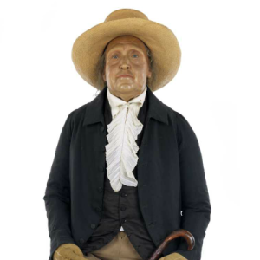
Jeremy Bentham resides in a cabinet on the ground floor of the South Junction close to the Provost's office.
You are looking at his preserved skeleton, dressed in his own clothes. Before you run from the building to summon the police, please be reassured that this is exactly what Jeremy Bentham requested in his will. It is called the Auto-Icon. Its head is made of wax - UCL Archaeology looks after his real head in climate-controlled conditions.
Famously, the Auto-Icon attends meetings of the College Council. Its presence is said to be recorded in the minutes with the words "Jeremy Bentham - present but not voting".
Good to know
- UCL has an project which is often described as 'Benthamite Propaganda' - and Jeremy Bentham needs YOU to get involved. His scribes are tweeting. (you have to hand it to the man - he takes to new technology like a duck to water).
- Note that the names of a few places in and around UCL contain 'Jeremy Bentham' - don't get confused between the pub, the room and the man in the cabinet.
- If you can't get enough of Jeremy Bentham in person, you can also play with him online.
Nearby
- The nearest set of stairs will take you down to the South Junction with its shops and nearby eateries.
- The offices of the Provost and Vice-Provosts (the Senior Management of UCL) are in the vicinity.
- An exit to a corner of Main Quad.

Next stop: Lush Cop
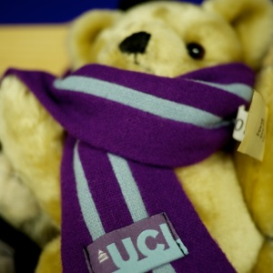
U _ L _ _ _ _
Now go there to find your next Inducktion poster.

You've arrived at the UCL Shop.
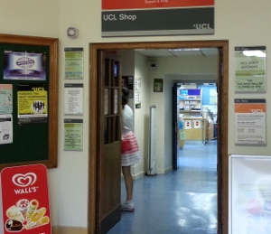
The UCL Shop is in the basement of the Wilkins Building near the South Junction. It's one of three shops on campus - the other two are run by UCLU. Here you can buy:
- Art supplies
- Basic computer supplies
- Stationery
- Food and drink
- UCL-branded things.
Find out more at http://www.ucl.ac.uk/estates/ucl-shop/
Good to know
- The Student Union - UCLU - also runs two shops on campus. You can find one in UCLU at 25 Gordon Street and the other also on Gordon Street below the Bloomsbury Theatre. For more information and opening times see http://uclu.org/facilities/shops.
- All the campus cash machines are located close to the campus shops.
- UCL WalkRunCycle have produced a helpful guide http://walkruncycleucl.wordpress.com/2012/02/29/campus-facilities-water-fountains-and-showers/
- Short of money? Consult UCLU resources on accessing hardship funding - http://uclu.org/hardship-funding. If you're able to work in the UK see UCL Careers Service collection of online jobs boards and UCLU's own Job Shop.
Nearby
- Because the South Quad is lower than the Main Quad the South Junction basement can be confusing - you're at ground level, but with a set of stairs also leading up to ground level.
- While you're in the basement foyer look around you - many noticeboards! Take a moment to look at them - you might be glad you did.

Next stop: Apricot for men


Clue: _ _ _ n _ _ o o _ C _ _ _
Now go there to find your next Inducktion poster.

Good navigating - you've found the Print Room Cafe.
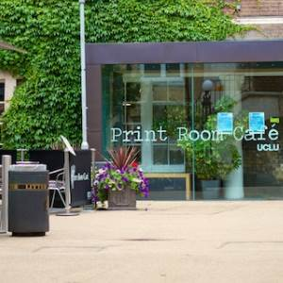
The Print Room Café is a café bar run by the UCL Union. It's located near the South Junction and has seating outside in the South Quad.
For opening times and menu see http://uclu.org/venues/print-room-cafe
Nearby
- SEnIT Suite - an IT workroom run by Student Disability Services - information at http://www.ucl.ac.uk/disability/SEnIT-Suite
- A cashpoint, at the bottom of the South Junction close to the UCL Shop.
- The JBS Haldane Student Hub - it's a zoned study space in the Anatomy building for individuals and groups, with or without computers.
Good to know
- All UCLU coffee is Fairtrade.
- We discuss food in more detail at another destination on this tour
- If you're in a UCLU club or society and you want to hold an event, the Print Room Café can be booked after 7pm. It holds 95 people.

Next stop: Soundproof Pretty Land
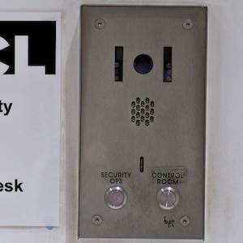

Clue: _ o s _ and F _ u _ _ P r _ _ _ _ _ _
Now go there to find your next Inducktion poster.

You've found Lost and Found Property!
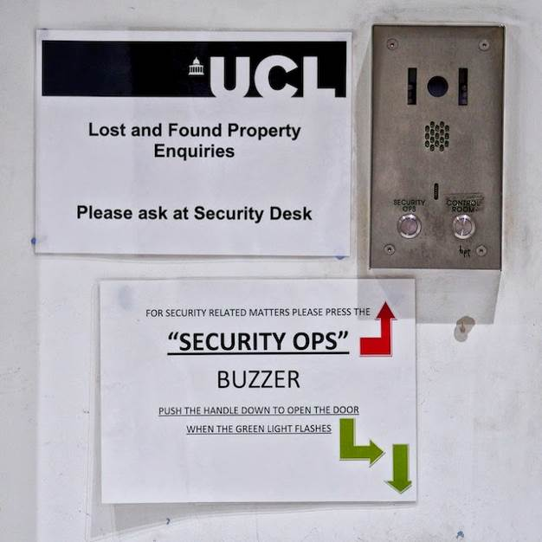
Lost and Found Property is located in the Security Operations Centre, Foster Court, Malet Place. This is where you can claim found property - to report lost property, you usually complete and email a form which you can find at http://www.ucl.ac.uk/estates/security/lost-property/
Good to know
- Around 10 items a week are reported lost or stolen - most are laptops, mobile phones, and bicycles.
- The staff of Lost and Found Property have plenty of stories. For example, students often leave their possessions unattended in UCL Libraries because they think that they are safe behind security systems. Many students also suppose that UCL has insurance against the loss or theft of student property.
- Neither of these assumptions is right - UCL is a public campus so it's important to keep your possessions with you at all times.

Next stop: Umpire met Sue
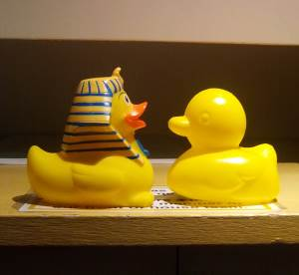
Clue: _ _ _ _ _ _ M _ _ _ _ m
Now go there to find your next Inducktion poster.

You've unearthed the Petrie Museum.
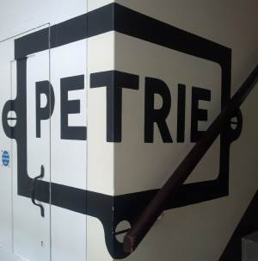
The Petrie Museum is located on Malet Place.
It's a world-class collection of Egyptian and Sudanese archeology, particularly famous for 'firsts' such as early linen from Egypt, early monumental sculpture, part of the earliest calendar, the first worked iron beads, and the first wills.
For more details visit http://www.ucl.ac.uk/museums/petrie .
Good to know
On Twitter you can follow The Petrie at https://twitter.com/PetrieMuseEgypt
6000 people follow The Petrie's Unofficial Page on Facebook at https://www.facebook.com/PetrieMuseum
The 3DPetrie team are researching 3D imaging techniques to allow museum visitors to interact with the exhibits in different ways. On Twitter that is https://twitter.com/3DPetrie
Nearby
- The South Quad which contains the Print Room Cafe and access to the back of the Anatomy Building.
- Lost and Found Property, The Institute of Making, the Science Library and the cafe in the Engineering Front Building are all on Malet Place.
- Computer workrooms - as well as the ones in the Science Library, there are also 60 computers in Foster Court B29.
- Bookable study rooms - you can book study rooms in the Science Library and in Foster Court. More at http://www.ucl.ac.uk/library/rm-book-top.shtml

Next stop: Resiliency Crab
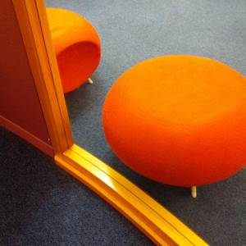

Clue: S c _ _ _ _ _ _ _ b r _ _ _
Now go there to find your next Inducktion poster.

Eureka - it's the Science Library!
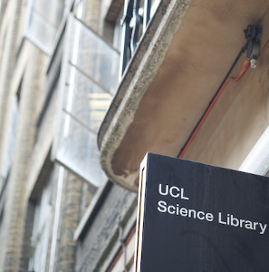
One of several library sites at UCL, the Science Library is located in the DMS Watson building on Malet Place. For details about its collections, opening hours, facilities, and accessibility, see http://www.ucl.ac.uk/library/science.shtml.

- You can find Library information for new starters at http://www.ucl.ac.uk/library/getting-started/
- You can use the self-service checkouts here - but first you need your username and pin number (more details about this at another tour destination).
- You can use a UCL computer here, as well as print, scan and photocopy.
- The ISD (Information Services Division) Helpdesk is here for walk-in inquiries about access to UCL's computers and wireless internet.
A word about internet and computers at UCL
- How do you get started? ISD has its own induction pages at http://www.ucl.ac.uk/isd/students/new-students
- How do you login? You need your UCL userid and password. To find your userid, have your UCL ID card to hand, and follow the instructions at https://myaccount.ucl.ac.uk/useridretrieve/
- Need wireless internet access? At UCL this is Eduroam, which works across many higher education institutions. Find out how to set up at https://www.ucl.ac.uk/isd/community/visit-conf/wireless/eduroam. Having trouble connecting? Ask at the ISD Helpdesk.
- Forgotten your password? Drop by the ISD Service Desk on the Science Library ground floor (you can also phone them) - details at http://www.ucl.ac.uk/isd/common/servicedesk
- Current computer availability across campus? The UCL Go app (http://www.ucl.ac.uk/isd/students/mobile/ucl-go) lets you check on your mobile device which computers are free around campus.
- Want a different computer room? A helpful map and summary of UCL computer workroom facilities is available at http://www.ucl.ac.uk/isd/students/workrooms/locations
- Which computers? The ground floor computers are available to all, the mezzanine is silent study with 74 workstations reserved for postgraduates.
- Printing? Your questions are answered at http://www.ucl.ac.uk/isd/students/print
And while we're here, a word about Portico - your online record and more. If you pre-enrolled, you may already know that Portico allows most students to privately access and manage your record at UCL including:
- Update contact details
- Select modules
- Find timetables
- Collect exam results
- And more.
All about Portico: http://www.ucl.ac.uk/ras/portico
Good to know
- Note the ISD (Information Services Division) Service Desk is different from the Library Assistance desk.
- There's a drinking fountain on Floor 2 at the end of the corridor.
- You've seen the Main Library and the Science Library - UCL has other Libraries too.
Nearby
- The Institute of Making, Malet Place - a club for people interested in the made world. There's a materials library and a workshop stocked with tools. UCL staff and students are free to join - you just need to complete an induction. Details at http://www.instituteofmaking.org.uk/
- The Engineering cafe, corner of Malet Place and Torrington Place.
- Group study spaces - for details of bookable spaces see http://www.ucl.ac.uk/library/rm_intro.shtml

Next stop: Trouble Finding Ring Engine

Clue: E _ _ _ _ _ _ _ _ _ _ F r _ _ _ B _ _ _ d _ _ g
Now go there to find your next Inducktion poster.

You have found the Engineering Front Building
Trouble Finding Ring Engine
The Engineering Front Building is located on the corner of Malet Place and Torrington Place. I've brought you here to tell you about some useful places nearby.
Nearby
- There's a cafe inside the building.
- The Bloomsbury Farmers Market is on Torrington Square / Byng Place on Thursdays, 10am to 2pm - details at http://www.lfm.org.uk/markets/bloomsbury/
- Waterstones is a large academic bookshop on Torrington Place. Show your UCL ID card for a 10% discount.
- Planet Organic is a grocers on Torrington Place which specialises in organic, vegetarian and whole foods. Show your UCL ID card for a 10% discount.
Elsewhere on this tour there's some more information about food.

Next stop: Cutesy System, Sir
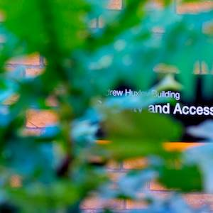
Clue: S _ _ _ _ _ _ y S _ _ _ _ _ s
Now go there to find your next Inducktion poster.

You've found Security Systems.
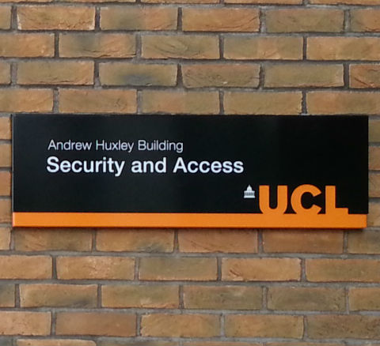
Security Systems is in the Andrew Huxley Building, on the east side of South Quad near to the Bernard Katz building. The nearest gate is on Gordon Street.
This is the part of Security which looks after access to buildings and some systems.
As a new student, you'll be instructed to collect your first UCL ID card from a different place - but if you lose that then you come here for a replacement (the first replacement is free, but you're charged for subsequent ones).
More information here: http://www.ucl.ac.uk/estates/security/systems/
Good to know
- Want to know more about how your UCL ID Card works? See http://www.ucl.ac.uk/estates/security/systems/identity-cards/.
- If the name on your card is incorrect, then contact the Registry first - only they can change it.

Next stop: Blueberry Maths Too

Clue: B _ _ _ m s _ _ _ _ T _ _ _ _ _ e
Now go there to find your next Inducktion poster.

Bravo, you've found the Bloomsbury Theatre.
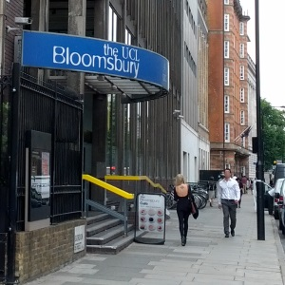
Owned and run by UCL, the Bloomsbury Theatre is at 15 Gordon Street. It is professionally equipped and seats 530. For 12 weeks of each year it is reserved for student performances - the rest of the time it's run like a West End theatre hosting a varied programme of comedy, drama, music and dance.
Details of facilities and upcoming events are at http://www.thebloomsbury.com/ - on Twitter you can follow https://twitter.com/bloomstheatre.
Good to know
- As you enter the building from Gordon St, note the staircase on your left leading down - this is a shortcut to the UCLU Shop and the Refectory.
- The Bloomsbury Theatre sometimes hosts UCL Bright Club, a monthly comedy and variety night performed by UCL academics - more at http://www.brightclub.org/
- There are some rooms here which can be booked by UCLU Clubs and Societies members via the UCLU Clubs and Societies Centre.

Also in this building
- The Bloomsbury Cafe
- Bloomsbury Fitness (the gym)
- The UCLU Rights and Advice Centre
- The UCL Student publication Pi Media - http://www.pimedia.org.uk/
- UCLU Clubs and Societies Centre (CSM)
- Cashpoint (in the basement)

Nearby
- Other UCLU services are located in nearby in 25 Gordon Street which is a little further north (towards Euston). That building has a cash machine, shop, hairdresser, bar and study space.
- At 185 Euston Rd, the Wellcome Collection with its galleries and events linking medicine and art. It has a library and cafe.
- The British Library is on Euston Road between Euston and St Pancras stations
- The Quaker Meeting House at 173-7 Euston Road has a cafe and restaurant serving vegetarian food - show your UCL ID card for a 10% discount.

Next stop: Architecture Cuddle Van Sign

Clue: _ _ _ _ _ _ _g h _ _ and A d _ _ _ _ C _ _ _ _ _
Now go there to find your next Inducktion poster.

You have found the UCLU Rights and Advice Centre

The University College London Union Rights & Advice Centre is located on the 1st floor at 15 Gordon Street - that's the same building as Bloomsbury Theatre (other UCLU services are further north at 25 Gordon Street).
The Rights & Advice Centre is a support service and a central point to obtain advice including:
- Academic - such as a Code of Conduct for Students, or information about what to do about examination irregularities
- Consumer - guidance for consumer problems
- Employment - such as who can work, and legal and contractual factors
- Financial difficulties - such as hardship funding
- Housing - such as finding accommodation, council tax exemption and housing law
- Immigration - staff offer specialist guidance for students from overseas
- Fortnightly legal service
- Small loans - may be available if you have exhausted other avenues
Further information, including detailed guidance and opening hours, can be found at http://uclu.org/services/advice-welfare .
Good to know
- Worries? Need emotional support? UCL has information, encouragement, guidance and links to help in person at http://www.ucl.ac.uk/support-pages
- Each UCL student has a Personal Tutor who has particular concern for your progression, development and welfare; your department will tell you who this is.
- The JobShop is UCLU's employment service - for a list of current job opportunities log in with your UCL userid.
- Parent or carer? See http://www.ucl.ac.uk/personaltutors/helpingstudents/studentservices/studentserviceschildcare
Nearby
- UCL Student Psychological Services is a few blocks away at 3 & 4 Taviton Street. They offer in-person counselling - see www.ucl.ac.uk/student-psychological-services/
- In other tour entries for this building we tell you about other interesting and useful destinations nearby.

Next stop: Fibrous Symbol Nest
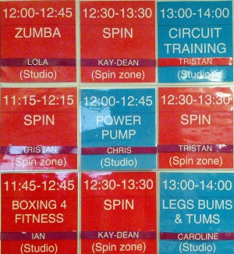

Clue: B _ _ _ _ s _ _ _ _ _ i _ _ _ s s

Now go there to find your next Inducktion poster.

Well done - you've worked out how to find Bloomsbury Fitness.
Bloomsbury Fitness is a fully equipped fitness suite located at 15 Gordon Street.

It has flexible membership, from 'pay as you go' day rates to annual membership.
Bloomsbury fitness I.F.I. accredited disabled accessible friendly including: treadmills, crosstrainers, bikes, resistance machines and free weights.
As well as 90 fitness stations there's a dojo and studio available for exercise and martial art classes.
More information can be found at http://uclu.org/bloomsbury-fitness
Good to know - active transport at UCL
- Need a bike? UCL WalkRunCycle - http://walkruncycleucl.wordpress.com/ - is a blog supporting active transport at UCL. It's a mine of useful information including where to get a second hand bike.
- Need to mend a bike? UCLU runs Bike Logic, a permanent free bike workshop on Hampstead Road and a pop-up every Tuesday outside the Print Room Cafe - http://uclu.org/bikelogic
- Need to park your bike? GreenUCL has a list (pdf format) linked from http://www.ucl.ac.uk/greenucl/resources
- Need a safe route to UCL? Consult WalkRunCycle at http://walkruncycleucl.wordpress.com/commuting-routes/
- Need a shower? GreenUCL has a list (pdf format) linked from http://www.ucl.ac.uk/greenucl/resources
- Need a drink of water? WalkRunCycle has a list of free water fountains and dispensers on campus - http://walkruncycleucl.wordpress.com/campus-facilities/
- Need a locker? Some departments offer lockers - ask your departmental administrator.
Nearby
- In other entries for this building we talk about interesting destinations in the building and nearby.

Next stop: Coy Ferret
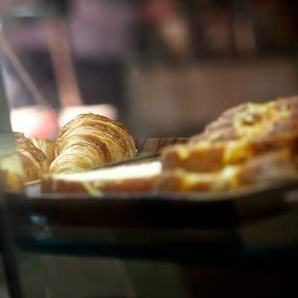
Clue: _ _ f _ _ _ _ _ y
Now go there to find your next Inducktion poster.

You've rooted out The Refectory!
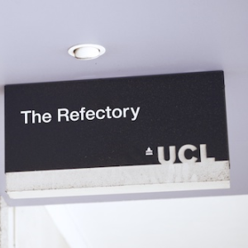
You can get a meal at The Refectory. Run by Chartwells, its entrance is via a covered walkway running below and next to the Roof Garden. Find out more about the Refectory at http://www.dineoncampus.co.uk/ucl/index.aspx
There's also a video tour of Chartwells campus eateries at http://www.youtube.com/watch?v=Eiphdlf9DvA
It offers:
- Tou Jours (freshly prepared baguettes)
- Trattoria (pizza and pasta)
- Chefs Theatre (selection of world cuisine)
- Goodness Me (salad bar and deli counter)
- Starbucks
- Amigos the snack shop.
Good to know
- Bringing a packed lunch? You are welcome to eat it in the Refectory and any other campus eatery. Some larger departments also have student common rooms, and there are informal hubs and study spaces including the Jeremy Bentham Room.
- Cooking on a budget? Some pointers. Consider pooling your budget with flatmates. See Student Cooking TV, which is a partnership between many UK universities. There's also 'A Girl Called Jack' and her 'Below the line recipes' and along the same lines, 'The Skint Foodie'. Food Cycle, where some UCL students volunteer, has good budget recipes. Use these keywords to find more information on the Web.
- Kosher? Halal? Vegan? UCLU provides certified sandwiches. There's also a lot of variety beyond UCL - UCLU Vegetarian Society, Islamic Society, Jewish Society, Hindu Society and Buddhist Society can also offer guidance about eating in the vicinity.
- Special diet for health reasons? For information contact Chartwells and UCLU.
- Short of money and food? In the very short term you can eat for free at lunchtimes outside SOAS (Thornaugh Street) thanks to the charity Food For All. And as soon as possible, consult UCL's resources on accessing hardship funding - http://www.ucl.ac.uk/current-students/money/
Nearby

- The covered walkway has a door onto a staircase and lift which leads up to the Jeremy Bentham Room, one of UCL's group study spaces.
- The Roof Garden is up some metal stairs at the Bloomsbury Theatre end of the covered walkway - you can sit and relax there, and there's an entrance to the South Cloisters near the Main Library.
- The Quaker Meeting House cafe and restaurant 173-177 Euston Road (opposite Euston station) gives a 10% discount for UCL students.
- Chartwells also runs the Engineering Cafe and the van in the Main Quad.
- UCLU's four cafes are The Print Room Cafe, The George Farha Cafe, The Bloomsbury Cafe and Gordon's Cafe.

Next stop: Ruggage Nuts
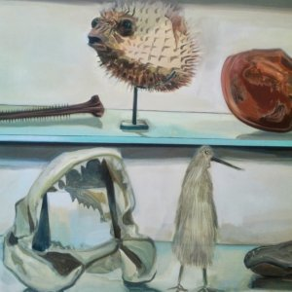
Clue: G _ _ _ _ _ u _ _ u _
Now go there to find your next Inducktion poster.

You've pounced on the Grant Museum!
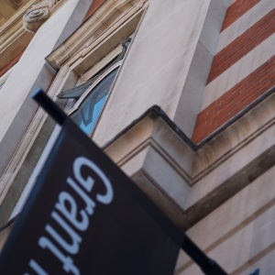
The Grant Museum is part of the Rockefeller Building on 21 University Street. Entrance is free of charge - take a look inside. For opening times and more information, see http://www.ucl.ac.uk/museums/zoology
Established in 1827 it's the only remaining university zoological museum in London and houses over 68,000 skeletal, taxidermy and wet specimens.
It's very hard to preserve marine invertebrates, which makes the specimens close to the entrance extremely interesting. Have a look - can you tell how they did it?
The Extinct & Endangered display includes a quagga, extinct in 1883. There's also a famous jar of moles. For more highlights see the museum's top ten objects.
Good to know
- Follow @GrantMuseum on Twitter.
- The Grant runs regular evening events including classic film nights, treasure hunts and panel games, as well as lectures and workshops. Details here: http://www.ucl.ac.uk/museums/zoology/whats-on
- The Grant Museum website invites you to send e-cards containing an exhibit picture and your choice of interesting fact about it.
- This is just one of several museums at UCL. Find out more on the UCL Museums & Collections web page - http://www.ucl.ac.uk/museums.
Nearby
- Across the road is a fine red-bricked example of Victorian gothic revival. Originally a hospital, the shape that gave the Cruciform Building its name was intended to allow light and air onto the wards. These days it's part of the School of Medicine but it retains some beautiful flooring, glazed bricks and decorative tiles. Its architect Alfred Waterhouse also designed the Natural History Museum.
- There are several teaching hospitals in the vicinity, all specialising in different conditions.
- Do you like pubs? The Jeremy Bentham (not to be confused with the JBR) is down the road at number 31 University Street.

Next Stop: Fear Hero Gag
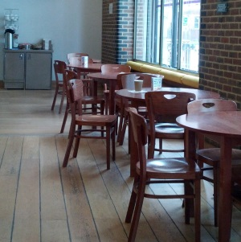
Clue: _ _ _ r g _ F _ _ _ _
Now go there to find your next Inducktion poster.

You have found the George Farha Cafe
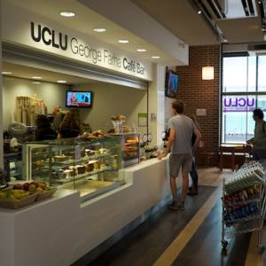
UCLU’s newest café is the George Farha Café Bar, located in the Lewis Building on Gower Street near Euston Square Station. It's named after a UCL alumnus who donates generously to places which educated him (hint, hint).
It serves refreshments and a bite to eat and like all UCLU outlets, Fairtrade tea and coffee.
For more information see http://uclu.org/facilities/cafes
Good to know
- Practising a musical instrument? For UCL Music Society members there are music practice rooms here in the basement of the Huntley Building and upstairs in the Bloomsbury building. Find out more from the Clubs and Societies Centre (CSC) in the Bloomsbury Building.
Also in this building
Some parts of UCLU we haven't seen yet including
- UCLU Volunteering
- UCLU Marketing & Communications
- The Huntley pub
- Richard Mully Basement Bar

Next stop: Trench Eel Hat
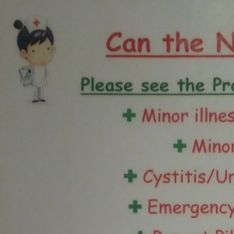
Clue: _ e a _ _ _ C _ n _ _ _
Now go there to find your next Inducktion poster.

Health Centre
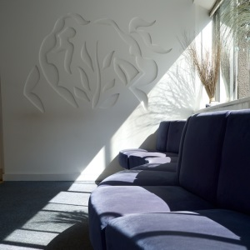
UCL Health Centre, also referred to as Gower Place Practice, is an NHS general practice located on UCL campus at 3 Gower Place.
Here you can access general health care, a contraceptive service, and a dental service.
Students have particular health care needs and this practice is specialised in these. It accepts patients from a wider area than other general practices, which means that you can stay registered throughout your course and don't have to find a new doctor and dentist whenever you change your address.
Staff of the Health Centre set out the importance of health care on campus at https://campaigns.uclu.org/health-centre/?page_id=106
More information about the general practice can be found at http://www.gowerplacepractice.nhs.uk/ and about the dental practice at http://thedentalcentrelondon.com/ucl-students/
Nearby
- Short cuts! Gower Court has entrances to many places including the back of the UCLU building, and the northerly end of the Wilkins Building North Cloister.
- Gower Street is round the corner, with the Grant Museum and the UCL main entrance.
- The Wellcome Collection is close by at 183 Euston Road - the galleries are free, and there's a cafe and shop.
- The Quaker Friends Meeting House is opposite Euston Station on Euston Road - its cafe and restaurant offer a 10% discount to UCL students.

Next Stop: Floss Duty Now
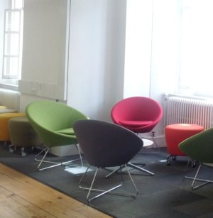
Clue: W _ _ f _ _ _ _ t _ y
Now go there to find your next Inducktion poster.

You have found the Wolfson Study
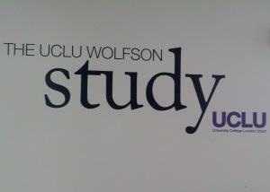
The Wolfson Study is a social study space located within the UCLU building on the corner of Gordon Street and Gower Place. Until recently it was a bar, but students voted to repurpose it. You're hard-working like that! Its name commemorates The Wolfson Foundation which made the refurbishment possible.
The Study comprises three distinct areas in which you can relax, chat, and study in groups or individually. Like all other UCL study spaces, you can get wireless internet access here - there are also some desktop computer workstations available for you.
Check out http://uclu.org/facilities/the-study for opening times and further information.
Good to know
- There are plasma screens and white boards for showing things to each other, as well as tables for group work.
- There are comfortable chairs and couches.
- The Study has a water fountain.
- There is 24-hour opening in the Summer Term - see the web site above for up-to-date details.
- Other study spaces include the Jeremy Bentham Room in Wilkins and the hubs which are planned for departments, of which the Anatomy Hub is one. You can also book study rooms - see http://www.ucl.ac.uk/library/rm-book-top.shtml
Also in this building
- UCLU Shop
- Cashpoint
- A Fine Cut Hair Salon
- Phineas Bar (3rd floor)

Start: Tender Nuts etc
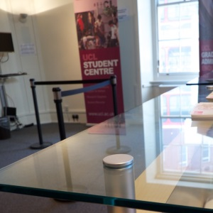
Clue: _ _ u d _ _ _ C _ _ _ _ e
Now go there to find your next Inducktion poster – or if you started there, to return to your starting place.

