The Danube region is home to many diverse fauna. The scarce human population on the Danube Delta has allowed many species to flourish in the region, however with Romania's growing economy and increasing population concerns are now being made. UNESCO estimates that the Delta sustains to over 300 species of birds and over 45 species of freshwater fish, many of which are unique and now unfortunately in a vulnerable position. Pollution, increased urbanisation, industrialisation and damming is causing problems for the species who live in the region and some special conservation programmes have been created. The World Wildlife Fund has coined the term the "Amazon of Europe" to describe the Danube.
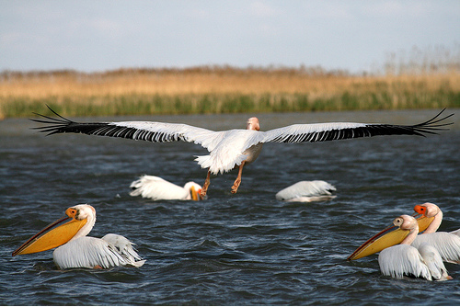

Sturgeon has been particularly badly affected from recent changes. The fish is popular due to its caviar. The fish is estimated to be 200 million years old and older than humans, but our relatively recent presence on Earth has diminished their stock. Many species of Sturgeon are already extinct and the future does not seem too positive for the Danubian Sturgeon either, with 1 lb's worth of the fish now selling for £2,800 due to its rarity. However some changes have been made - it is now illegal to fish Sturgeon in the Romanian Danube region.
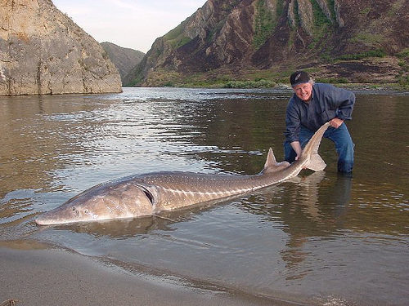
The abundance of various species of fish in the area attracts the Dalmatian Pelican (Pelecanus crispus) to the region during the summer months. The total population of the species is estimated to be 20,000. In the past 1,000,000 Dalmatian Pelicans were said to live in the Romanian Danube region. Depleting fish stocks and human poaching is often blamed for the species vulnerability. Conservation efforts are now being made and platforms have been placed on land and rafts in the Delta’s waters to try and encourage breeding within the species.
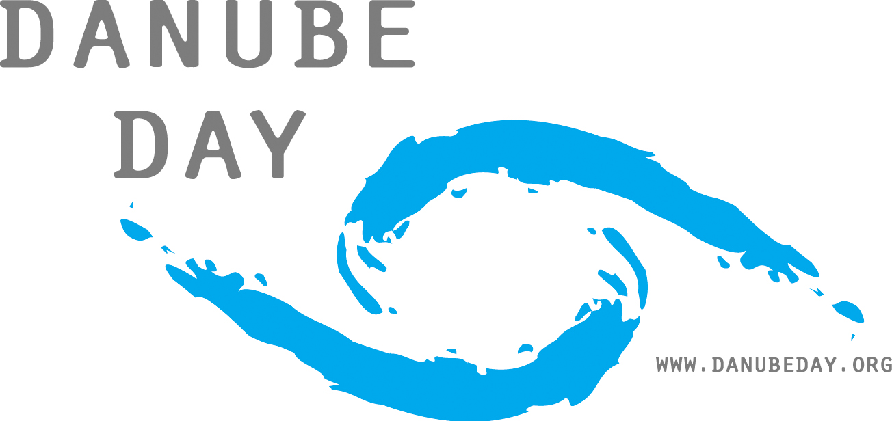

The European Union has released so called "Odessa Conclusions" which gives advice regarding which steps the governments should take to protect the region. It recommends alternative economies for local people to promote sustainable growth which does not affect the local ecosystem, cross-border co-operation and sustainable sectoral activities in agriculture, transport, energy etc. An event labelled the "Danube Day" has also been created to celebrate a "cleaner, safer river" after 18 years of co-operation between neighbouring nations. Non-governmental organisations such as the WWF remain concerned and call for more stringent rules, citing the fact that the numbers of certain species have started to diminish and the region's unique ecosystems are at risk of being irreparably damaged.

