POTENTIAL FOR A NEIGHBOURHOOD INCOME-BASED DOMESTIC ENERGY MODEL FOR ORDINARY ELECTRICITY USE IN ENGLAND

Stephen William Lorimer

University College London Energy Institute, 14 Upper Woburn Place, London WC1H 0HY, United Kingdom, s.lorimer@ucl.ac.uk

#### Summary

Current domestic energy models in England currently only take floor area as an independent variable in modeling electricity consumption of a home. This work compared the algorithm in place from 2001-2005 with surveys of consumption in homes from 2002-2006 and census area-wide consumption for the year 2007 to examine the effectiveness of the model and the potential for improvement by adding in the variable of average income by area. The results were that the model underestimated consumption, and the survey did not match the amount of consumption in census areas at the top of the income scale.

Keywords: electricity, modeling, income, neighbourhood, area

# Purpose and data sources

Building regulations are required to promote the conservation of energy use in domestic buildings in England. For domestic buildings, this is the Standard Assessment Procedure based on the Building Research Establishment Domestic Energy Model - 12 month (BREDEM-12) [1]. This paper seeks to examine the potential for income to be included as a factor in estimating what is called “ordinary” domestic electricity use in England by examining homes that were surveyed during the time that the BREDEM 2001 model was in force. Ordinary electricity use is approximated as the electricity use of lights, appliances, and cooking in the homes.

There are three main data sources. The UK Department of Energy and Climate Change developed a method of measuring small areas in England for electricity and gas in annual kilowatt-hours [2]. The English House Condition Survey (EHCS) is a national survey of housing in England involving both an interview and a physical inspection of property by professional surveyors. [3]. Other data has been extracted for information on trends in electric and gas fuels for cooking [4].

# Methodology

Electricity consumption data covering all housing in England is currently released at the level of the Middle Layer Super Output Area (MLSOA) – around 2,000 households. This exercise will compare reported electricity use for ordinary electricity use at the MLSOA with EHCS data and modelling predictions from BREDEM-12 (2001) contained in the planning and building regulations in force from 2001 to 2005 [5]. To make this comparison, a new dataset for each MLSOA will need to derived building upon survey and census data. Table 1 describes the data required.

|  |  |  |  |  |
| --- | --- | --- | --- | --- |
| **EHCS (unit scale)** | **Regional Price Index (RPI) (Regional scale)** | **Census data (MLSOA scale)** | **EHCS/RPI/Census Derived Dataset (MLSOA scale)** | **DECC Energy Data (MLSOA scale)** |
| Region | Region | Region | Region | Region |
|  |  | MLSOA name | MLSOA name | MLSOA name |
| Dwelling type |  | Dwelling type | Dwelling type |  |
| Area Type |  | Land Use | **Area Type** |  |
| Gross Floor Area |  |  | **Gross Floor Area** |  |
| Household Income |  | Household Income | **Income group** |  |
| Cost of ordinary electricity use | Price per kilowatt-hour |  | **Total ordinary electricity use** | Total ordinary electricity use |
| Method of payment | Method of payment |  |  |  |

Table 1: Referenced and Dervied datasets (Plain = given data **Bold = derived data)**

As shown in Figure 1, The EHCS/RPI/Census derived dataset needs to both be able to produce an estimate for total residential ordinary electricity consumption for each MLSOA through analysis of the survey data and by running a large version of the BREDEM algorithm based on numbers of people, floorspace, and electric cooking trends.

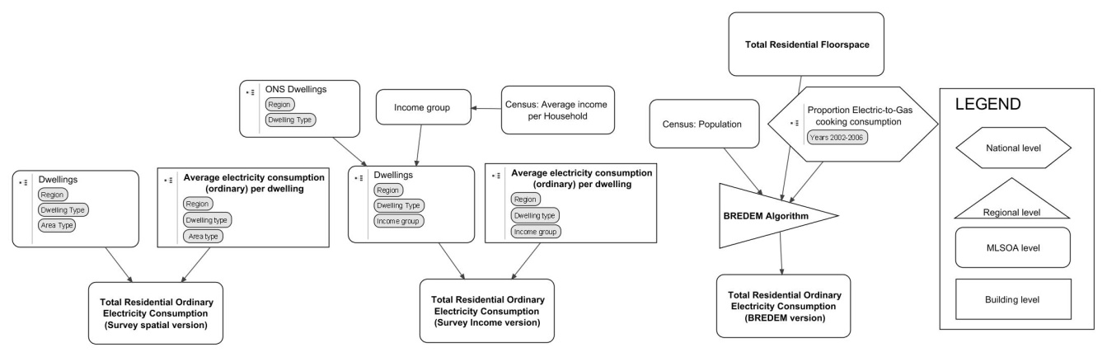

Figure 1: Residential electricity consumption estimates and derived dataset requirements (in bold)

Data obtained on each dwelling in the EHCS were the English region, dwelling type (e.g. detached house), area type (urban, surburban, and rural), household income level, payment type for electricity, and spending on appliances and lighting and cooking, which is closely connected to annual spending on ordinary electricity use. The annual spend on electricity in each dwelling was converted to annual kilowatt-hours based on regional energy price data. A mean ordinary electricity consumption per dwelling was averaged by region, dwelling type, and household income group. National trends on ownership and usage of hobs and overs were merged to create a proportion of electric-to-gas cooking consumption per year [4]. Figure 2 describes this process.

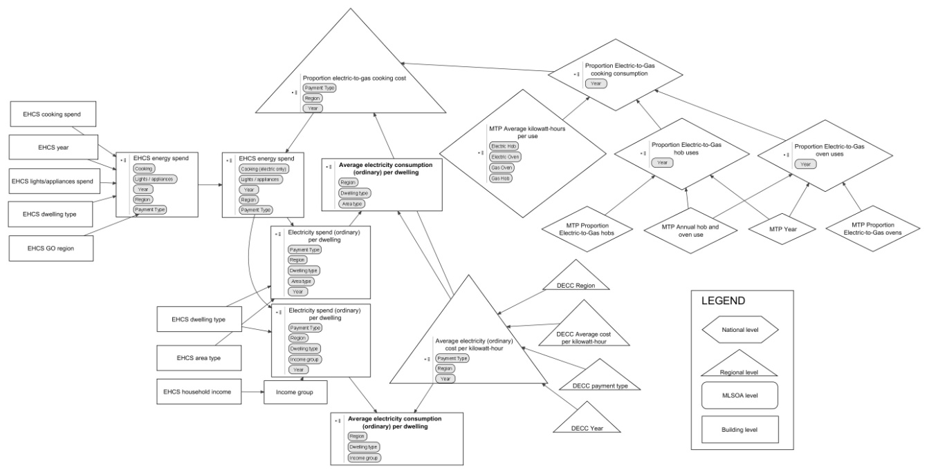

Figure 2: Calculating average ordinary electricity consumption per dwelling

# Results and Analysis

For each MLSOA, the three estimates of total electricity use per household (survey - spatial version, survey – income version, and BREDEM 2001) were plotted against:

* Total residential floorspace times population divided by households, which equals the floor area times numbers of occupants per household
* Income per household

**Findings**:

1. The planning and building regulations in force from 2001-2005 underestimated the ordinary electricity consumption of households by half of both the reported energy use in the surveys, and also by half or more the average electricity use per household reported in each MLSOA (the DECC data) as shown in Figure 3.
2. Both BREDEM and the survey data show a similar increase in consumption in proportion to floor area and numbers of people as in the DECC data indicates.
3. When the EHCS survey, DECC data, and BREDEM electricity totals per household are plotted against income per household, the survey and BREDEM estimates show less increase in energy use based on income compared with the DECC data as shown in Figure 3.

Discrepancies are the largest in higher incomes and therefore income is valuable for estimating electricity consumption in high income areas. The spread of individual homes’ electricity use in the EHCS against household income shows an even spread of homes surveyed against both variables. The income of the homes surveyed by the EHCS from 2002-2006 is often significantly less than the average household income in the same region. The index of net household wealth per head more than doubled between the early 1990s when the BREDEM 2001 version was first in development, and the mid-2000 when the EHCS and DECC data was taken [6].

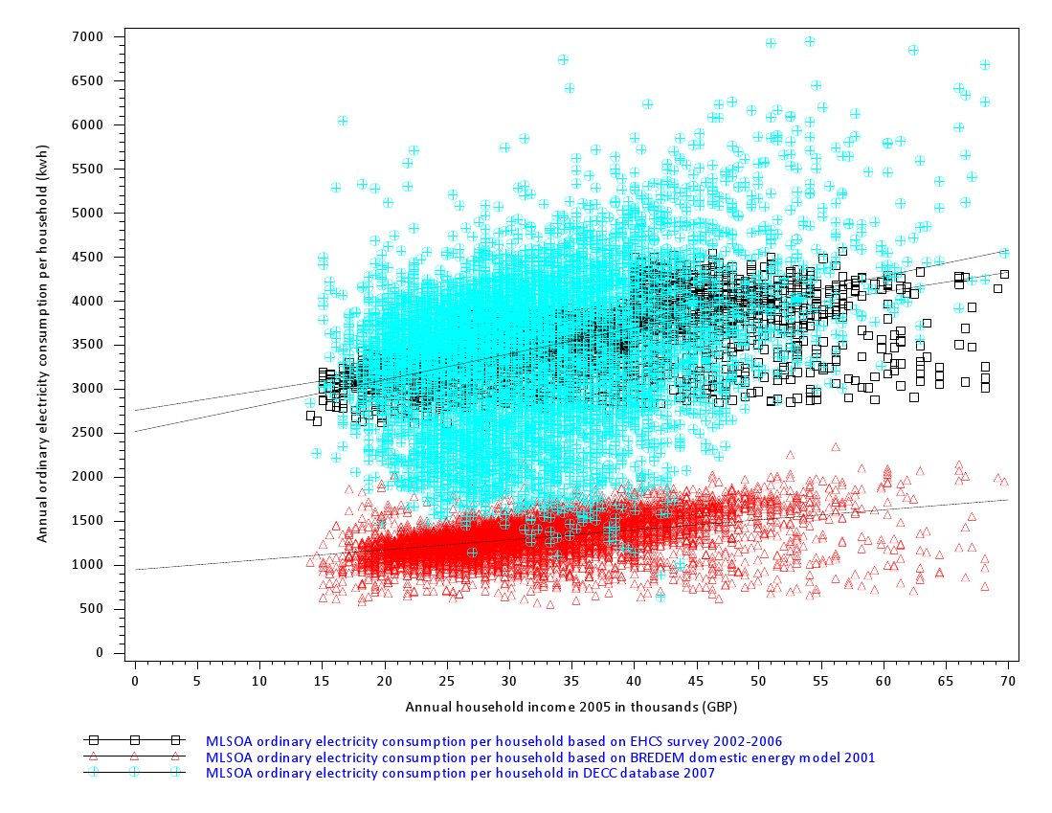

Figure 3: electricity consumption per household v income per household for 6758 MLSOAs  
Regression Equation (EHCS): Electricity = 2750.521 + 22.43517*Income R2=0.3834  
Regression Equation (BREDEM): Electricity = 942.5958 + 11.34131*Income R2=0.1757  
Regression Equation (DECC): Electricity = 2512.243 + 29.44699*Income R2=0.0572

# References

[1] Department for Communities and Local Government, The Building Regulations 2000. Conservation of fuel and power. Approved document L1A, 2006 ed. ed., NBS, London 2006.

[2] Department of Energy and Climate Change, Guidance note for the DECC MLSOA/IGZ electricity and gas consumption data, in: D.f.E.a.C. Change (Ed.), London 2009.

[3] Department for Communities and Local Government, English House Condition Survey (EHCS), Department for Communities and Local Government, London 2010.

[4] Market Transformation Programme, BNCK01: Assumptions underlying the energy projections of cooking appliances, 3.2 ed., Didcot, UK 2008.

[5] B.R. Anderson, BREDEM-12 : model description, 2001 update, CRC, London 2002.

[6] Office for National Statistics, Social Trends 2009, London 2009.